WV Commision
Solution Design Document

Prepared For



PREPARED BY
Nitish Pandey

July 2024

MODIFICATION CHANGE HISTORY
 | Description Of Change | Date Of Release | Change Request | Version | Approved By
1 | Initial Draft | xx/xx/2024 |  | 1.0

Contents
1. Document Overview 5
a. Business Objectives 5
b. Purpose & Scope 5
c. Design Principles 5
d. Key Design Decisions 5
2. Functional Scope 6
a. In Scope 6
b. Out of Scope 6
c. Items to be discussed 6
3. Technical Scope 7
a. General Setup 7
b. Custom Development 7
c. Data Migration 7
4. Process Flow and Requirements 8
a. High Level Process Diagram 8
b. Feature Overview 9
5. Use Cases 10
6. ERD and Security 16
a. Objects 16
b. Object Relationships 17
c. Profiles 17
d. OWD 17
e. Object Permission 18
f. Sharing Rules 18
7. Use Case Solutions 19
a. R1-UC-001 - Create/modify Transaction 19
b. R2-UC-002 - Create/modify Transaction 21
c. R3-UC-003 - Create/modify Transaction 24
d. R3-UC-004 - Create/modify Transaction 26

8. Error Handling 38
9. App Level Configuration 39
10. Reporting 39

Document Overview

Business Objectives
Wealthvest collaborates with multiple financial companies, referred to as carriers, to offer their products to investors. In this process, Wealthvest works with numerous agents who facilitate the sale of these products. Wealthvest's commission engine, built on the Salesforce platform, plays a crucial role in this ecosystem. It helps identify the commission for each partnered entity for every successful investor. The commission is determined based on multiple criteria, including the level of the agent, the product, the year of investment, the age of the investor, the state, and many other factors.

Purpose & Scope
The purpose of this Solution Design Document (SDD) is to provide a high-level design for the WV Commission implementation. This document is based on demos by IT and user meetings. The requirements identified in these meetings were analyzed to derive the design for the following aspects of the system.
- User Experiences for the key user stories
- Data model
- Application configuration and customization to achieve functionality within the user stories
- Security model and design
- Reports & Dashboards

Design Principles
- The data model design should support future scalability and extensibility.
- The data model should support all the payment structures for various business groups of Disney.
- The master data model design (Account, Contact, Product Line, Product, TImeframe and relationships between them) should support real world scenarios. For example a Carrier can be associated with multiple Product lines, transaction and payments should have accurate data based on the calculation and commission provided on master data.
- There should be an effort to not duplicate fields across the application which have the same or similar meaning.
- Refrain from over engineering. Provide a solution that is good enough and functionally acceptable by the target end users.
- Keep the user interaction model consistent with respect to screen layouts, tabs, field positions, buttons, links, pop-ups etc.

Key Design Decisions
- The goal is to use Salesforce platform solutions that are scalable and easy to configure with less maintenance.
- Any Salesforce platform limitation will be overcome by building custom lightning component to satisfy the business requirement.

Functional Scope

In Scope

Business process that are in scope:
- Transaction creation
- Payment creation
- Reprocess payment
- Configure commission settings
- Reporting

Out of Scope

Business process that are out of scope:
- Outbound Integration

Items to be discussed

Following business process needs to be further discussed to define the solution:
- XYZ.

- XYZ.

Technical Scope

General Setup
• Setup Account, Contact, Product Line, Products
• Setup Users, Role, Profile
• Object Creation.
• Reports

Custom Development
- Custom Lightning Components:
- Transaction:
  - Reprocess : cm_ReprocessActionbutton
  - Process : cm_TransactionProcess

- COC Report

- Apex Triggers
- Transaction : BatchLineItemTrigger

- Apex Classes

Data Migration

Object Label | API Name | Description
Payment
Transaction

Process Flow and Requirements

High Level Process Diagram

The following diagram depicts the high level process flow:

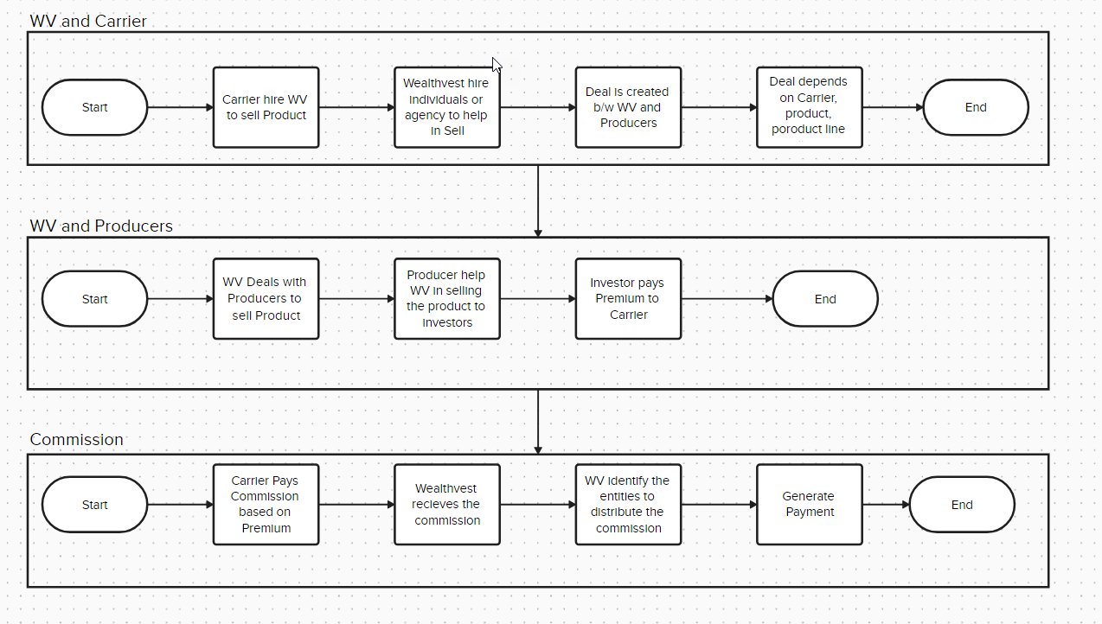

The following diagram depicts the high-level ER Diagram:

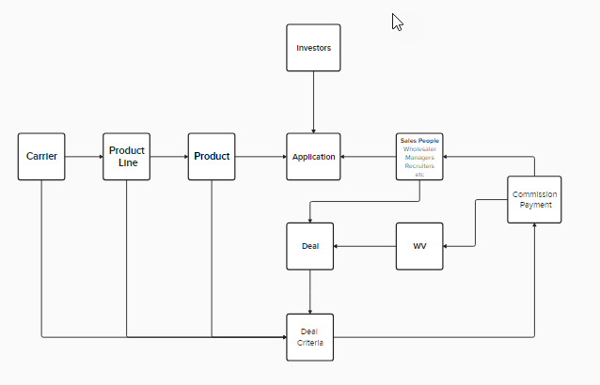

Feature Overview

As a result of requirements gathering session conducted with the Finance department of FX, below are the high level requirements:
Number | Details | Comments
R1 | Ability to create/modify Transaction | Must Have
R2 | Ability to create/modify Transaction | Must have
R3 | Ability to create/modify Transaction | Must Have
R4 | Ability to create/modify Transaction | Must Have

Use Cases

Use Case | Steps
R1-UC-001 - Create/modify Transaction | - Create Transaction from .Net Application:
R2-UC-002 - Create/modify Transaction | - Verify payment is not correct:  - .

ERD and Security

Objects
The following table provides the details on Salesforce objects to be utilized for Payment Solution:
Object | Type | API Name
Account | Standard | Account
Contact | Standard | Contact
Product LIne | Custom

Object Relationships
The following ERD depicts the core objects and their relationships:

Profiles
Based on different functional department, following separate profiles will be setup:
- XUYZ: ABC
- XYZ: ABC.

OWD
OWD is the primary layer of security in salesforce, also if the relationship between the objects is Master-Detail, then OWD is inherited by its Parent. OWD for different Object will be as follow:

Object | OWD
Account | Public Read Write
Contact | Public Read Write

Object Permission
Object Level Permission in Salesforce is handled by profile. The object level permission will be as follow:
Object | Profile 1 | Profile2
Account | Modify All | Modify All
Contact | Modify All | Modify All

Sharing Rules
If any object is private, then only owner can view the records. If we need to make record available for entire group then we need sharing rules. Sharing rules give the capability to modify the visibility of records based on several criteria or based on Owner. We can share the records with Roles or group.
Following Sharing rules need in BLAST:
Object Name | Criteria | Share with

Use Case Solutions

R1-UC-001 - Create Transaction
About Transaction
- Transaction object is created from .Net application. It contains the application information, Policy number, commission rate, amount, producer etc.
Business process:
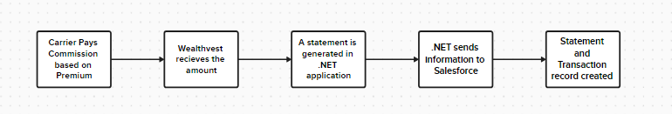

Key Fields used in Transaction:
Field Name | Type | Description
Application | Lookup
Contract | Lookup
PALI | Lookup
Producer | Lookup
Policy Number | Number
Base premium amount | Number
Rate | Percentage
Deposit Amount | Number
Parent Object of Transaction
Relationship Type | Object | Description
One to One | Statement | Statement object is the summary about the payment from Carrier to WV
Many to One | Carrier | Carrier introduces the products
Many to One | Application | Application is submitted by the investor with the help of producer. It has information about product, product option, Carrier etc
Many to One | PALI | PALI is the child record of Application that has all the details about the related entities that helped with the application
Many to One | Product | Product information
Many to One | Producer | Producer who helped with the application
Many to One | Product Option | Child of product that has offering information
Many to One | Contract

Child Object of Transaction
Relationship Type | Object | Description
One to Many | Payment | Payment is the child of transaction that has information about the commission share to each entity

Following Lightning page Layouts will be needed:

Project Page Layout for | Related List | Buttons
Unprocessed
Proccessed | Payment | Process, Reprocess
Workflow:

Scenario | Entry Criteria | Action
Create Payment | Include=True and Payment Posted =True | Create Payments

Unprocessed Transaction
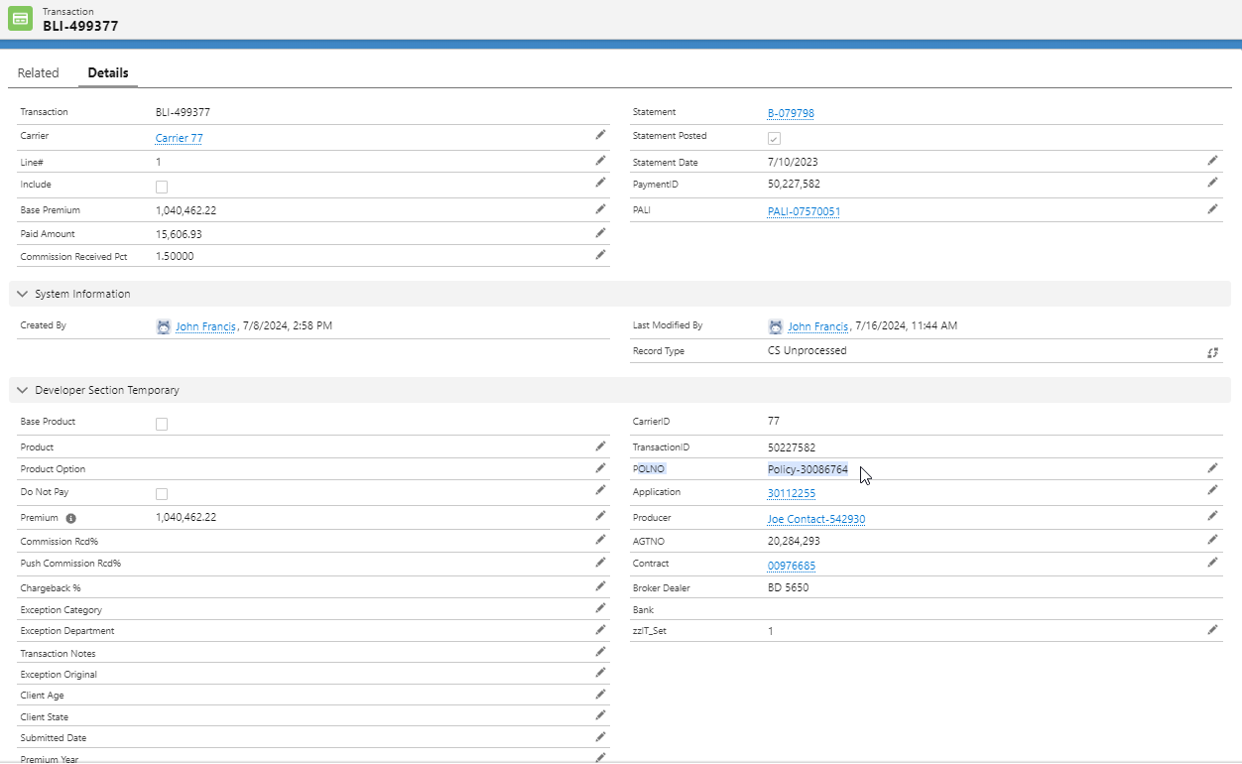

Processed Transaction
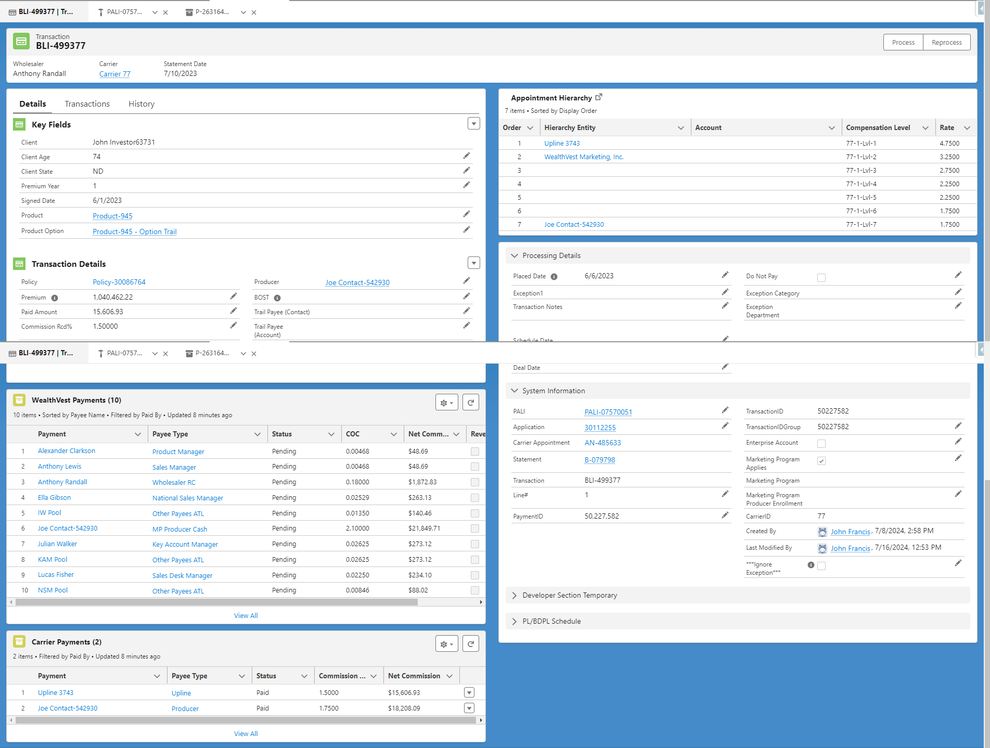

R2-UC-002 –Payment Creation from Transaction Trigger

About Payment:
Payment is the child of transaction. It is created by the trigger on transaction Object. First it checks if “Include” field and “Statement Posted” is true, then the business logic initiates,

Flow Diagram when trigger executed:

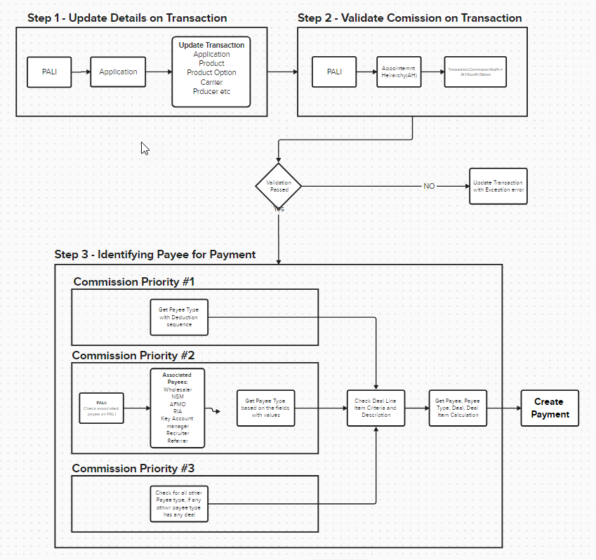

ER Diagram with Process flow:
- When Transaction is created, it first updates the fields on Transaction from PALI and Application Object
- System checks if the commission percentage is correct. Appointment Hierarchy is used for validation.
- Get Payee type for deductions
- Query from PALI for all related Entity based on the lookup fields and roles
- Get the Deal Line item to see whom we need to pay
- Create Payment based on the Deal Line item

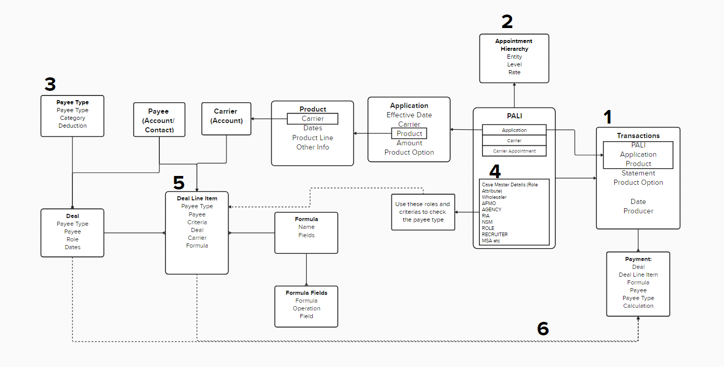
Transaction Record Type:
Record Type | Description
CS Processed | Record type when Transaction is processed and Payment is generated
Some Common Fields of Transaction used in creating payments:
Field Name | Type | Description
Include | Checkbox
Statement Posted | Formula(Statement.Posted__c)
Important Fields on payments:
Field Name | Type | Description
Paid by | Picklist | Carrier; Wealthvest
Payee | Lookup (Account/Contact)
Payee Type | Lookup
Transaction | Lookup
PALI | Lookup
COC | Percentage
Deal | Lookup
Deal Line Item | Lookup
Payee Type Criteria | Lookup
Formula | Lookup
Commission Cycle | Lookup
Apex Trigger
Trigger Name | Object Name | Decription
BatchLineItemTrigger | Transaction (BatchLineItem__c) | Trigger on Transaction Object to update application status, Update transaction fields based on Application and PALI.  Also creating payment records.

Apex Class List
Apex class | Method name | Decription
BatchLineItemHandler |  | Handler class for Trigger
CM_Utility |  | Utility class contains multiple methods. Class has all the logic related to update transaction field, validate record for any error and also creating the payment.
CM_InitializeTransactionProcessBatch |  | Batch class, it identifies the source of action and based on the source perform some update on transaction and eventually create payment
UpdateApplicationStatusFromBatch |  | Class has the logic to update Application status
CM_PaymentUtility |  | Class contains all the method related to payment logic
CM_AppointmentHierarchyCtrl |  | Class that gets the Appoint hierarchy logic
CM_Engine |  | Has the logic for transaction and COC reports
CM_EnginePaymentUtility |  | Class contains the method related to payment calculation
CM_EngineDealUtility |  | Class has method related to deal and deal line item

R2-UC-003 – Reprocess Transaction

About Reprocess:
If the COC is incorrect, User can update the COC, Product or Product Option and calculate the payment based on the latest data on Transaction.

Flow Diagram:

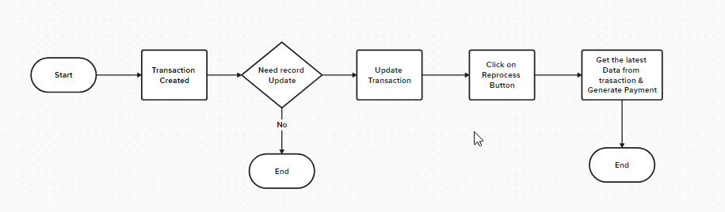

Record Type:
Record Type | Description
CS Processed | Record type when Transaction is processed and Payment is generated
Some Common Fields used in creating payments:
Field Name | Type | Description
Application
PALI
Product
Product Option
Significant Relationships:
LWC Component
LWC Name | Decription
cm_ReprocessActionbutton | Used on button “Reprocess”. When there is any change made on the transaction and payment has to be created using the new information, this button is used. Changes like Product change or Product Option change etc.
Apex Class List
Apex class | Method name | Decription
CM_TransactionProcessCtrl | csProcess | Validate if record can be processed and then call utilityclass method for further processing

Screenshot:
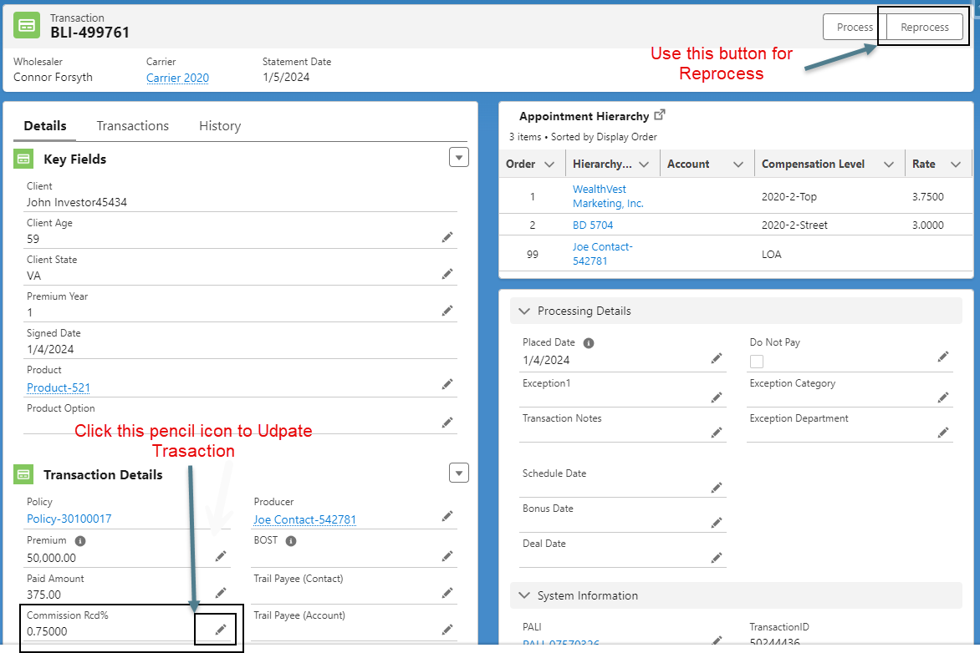

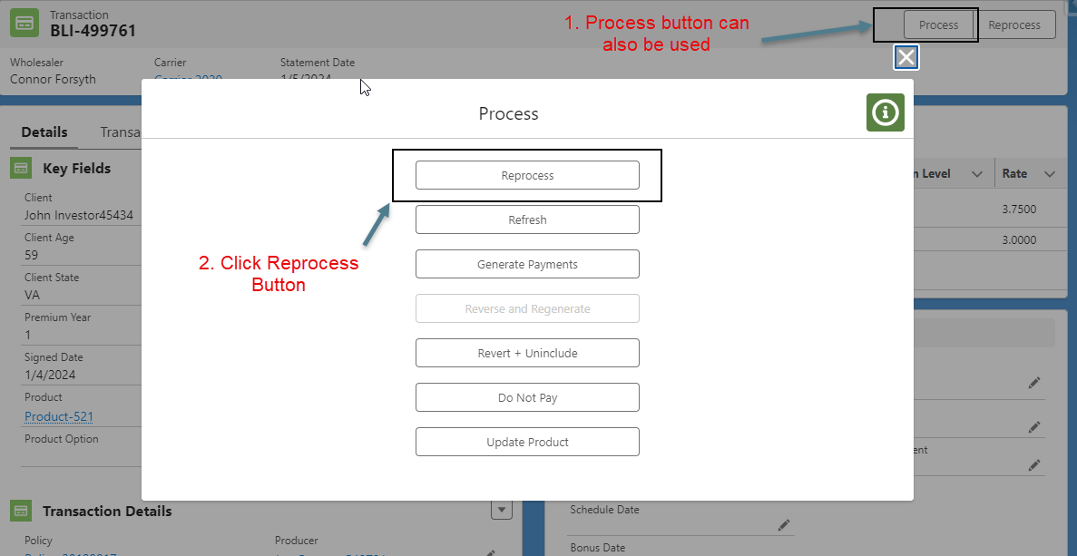

R2-UC-004 – Process Transaction

About Process:
If there is any issue with the Transaction, there is a button Transaction with Processed Record type. Once user clicks user gets multiple options:
- Reprocess: Create Payment based on the data on the Transaction
- Refresh: Remove the config data from the Transaction and update the configuration again and generate payment
- Generate Payment: Create payment with a user generated label
- Revert and Regenerate: User selects the Payment from the list, provide a label. System clone the selected record, revert the previous record and update Label
- Revert and unincluded: Remove the config data from the Transaction
- Do not Pay: and delete all the unpaid payment and update Do not pay to false
- Update Product: Update Product and Product Option. Also update the Timeframe and timeframe Schedule. Generate payment

Flow Diagram:
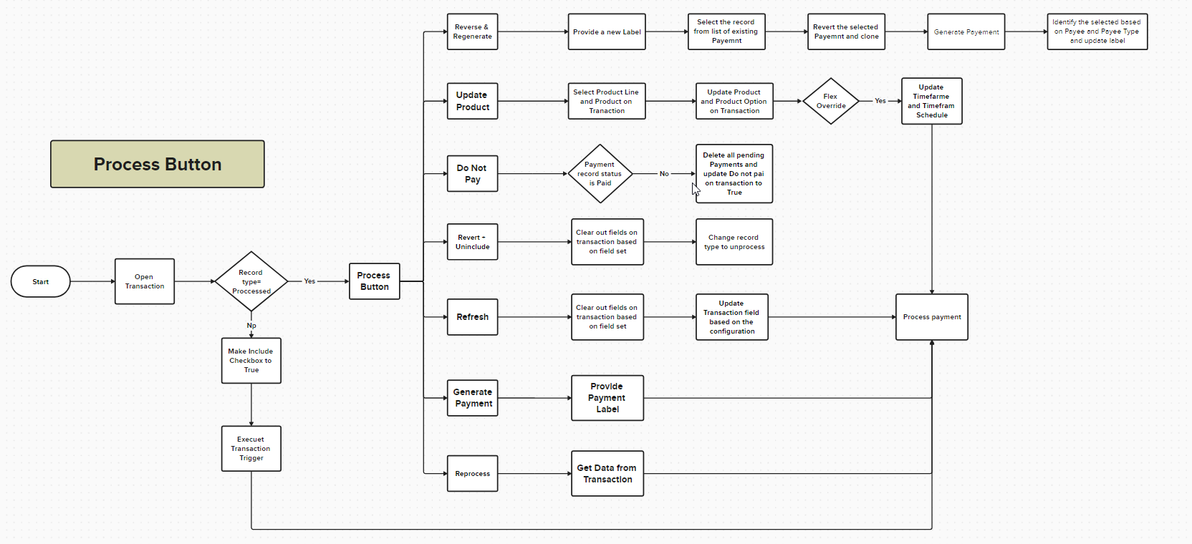
Record Type:
Record Type | Description
CS Processed | Record type when Transaction is processed and Payment is generated
LWC Component
LWC Name | Decription
cm_TransactionProcess | Used on button “Process”. Shows multiple options like Process, Reprocess, Do Not Pay, Revert, Update Product, Reverse and Regenerate, Generate Payment

Apex Class List
Apex class | Method name | Decription
CM_TransactionProcessCtrl | csProcess  csSetDoNotPay  csReverseAndRegenerate  csGeneratePayments  csRevertAndUninclude  csFetchAllProductLine  csFetchAllProductLineTimeFramesProduct | Validate if record can be processed and then call utilityclass method for further processing
CM_Utility | csTransactionSetDoNotPay  csTransactionRevert  csReverseRegenerateTransaction  csGeneratePayments | Utility class contains multiple methods. Class has all the logic related to update transaction field, validate record for any error and also creating the payment.

Screenshots:
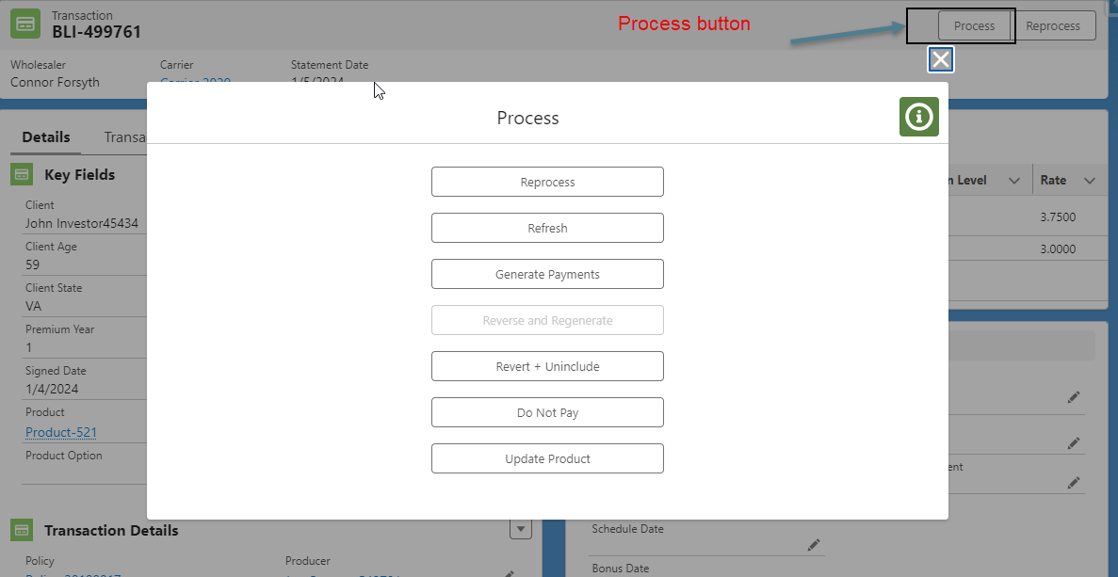

Update product
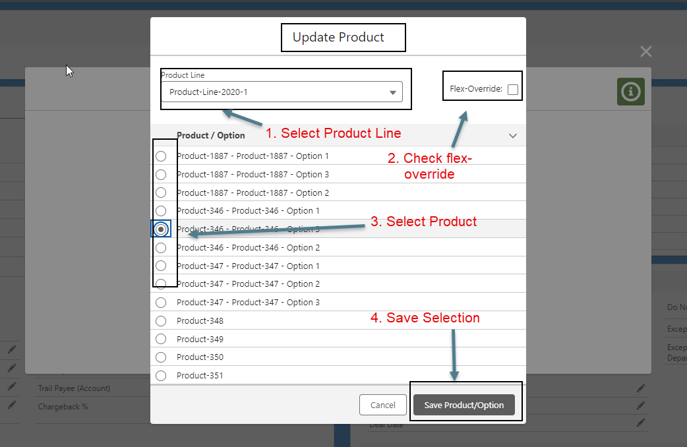

Generate Payment:
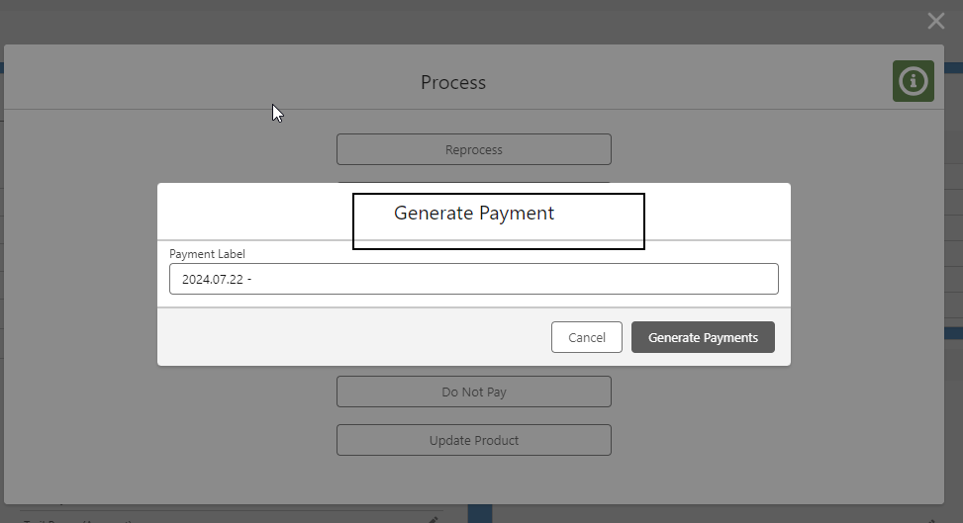

R2-UC-005 – COC Report

Record Type: The Record Type will be used to distinguish between the various types of talent across the various divisions of FX group.
Record Type | Description
CS Processed | Record type when Transaction is processed and Payment is generated
Some Common Fields used in Talent/Contact:

Field Name | Type | Description
Significant Relationships:
Relationship Type | Record Type | Object | Description
Talent/Contact will have common layout for all profiles. Following Lightning page Layouts will be needed:
Record Type | Related List | Buttons

Screenshot
ABc.

Error Handling
Salesforce generally handles all types of errors, if functionality is out of box. But for custom coding there is no out of box way to handle the errors. Developers need to make sure that exceptions are handled.
- Logged in User
- Object where error occur and the record id.
- Exception details etc.

App Level Configuration
Following table is an overview of Mapping for several app level configuration between K2 and BLAST.

Commission Configuration Name | Description

Reporting
Following reports types will be set-up for payment functionality to provide business insights and to filter on available metadata.

